Project Summary

Jeremiah Nofrada

Git: <https://github.com/jnnofrada/finsta.git>

Last Commit date 12/11/2019

Team Members: 1

Jeremiah Nofrada; jnn247

1. Feature 1
   1. Project 12: Add Friend Group
   2. Jeremiah Nofrada
   3. 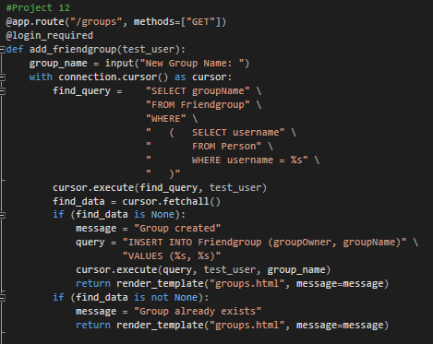
   4. Function commented with “Project 12”
2. Feature 2
   1. Project 13
   2. Jeremiah Nofrada
   3. 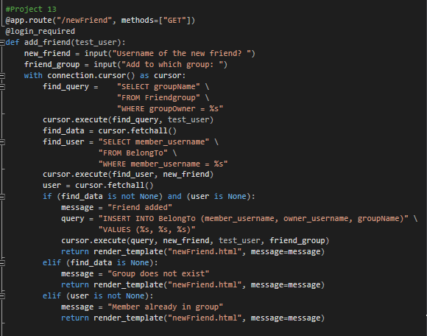
   4. Function commented with “Project 13”